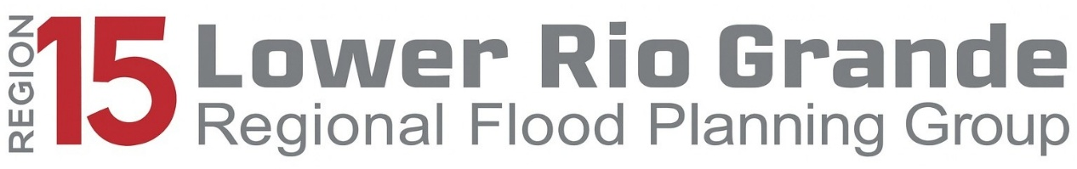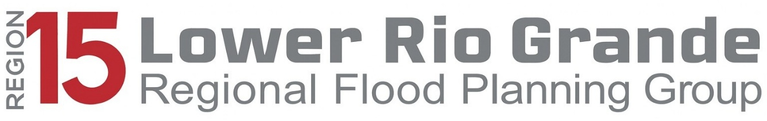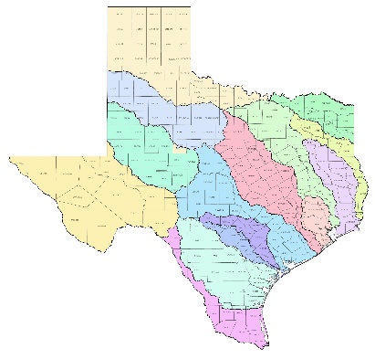

**EXECUTIVE BOARD MEMBERS**

David A. Garza, Chair

Cameron County

David L. Fuentes, Vice Chair

Hidalgo County Drainage Dist.

Vacant, Secretary

**VOTING MEMBERS**

Jose Caso - Caso Law Firm

Laura Haley - Haley Law Firm

Joe Califa

Rene Estrada - City of Combes

Joey Trevino - RGV AGC

Alan Moore - CC Drainage Dist.

Hudson DeYoe - UTRGV

Daniel Lucio - AEP Texas

David A. Garza – Cameron Co.

Ernie Garcia – Willacy Co.

Raul Pena, Jr - Starr Co.

**NON-VOTING MEMBERS**

Kristina Leal - Halff Assoc.

Anne Whitko - Halff Assoc.

Nick Collins - TWDB

Ramon Macias, III - IBWC

Shonda Mace - GLO

Willy Cupit - TPWD

Lupita Ramos - STDC

Tim Frere - TDEM

Nelda Barrera – TX Dept. of AG

Adrian Perez - TSWC

Manny Cruz – LRGVDC

*Executive Director*

David Ramirez - TCEQ

*Area Director*

*Border & Permian Basin*